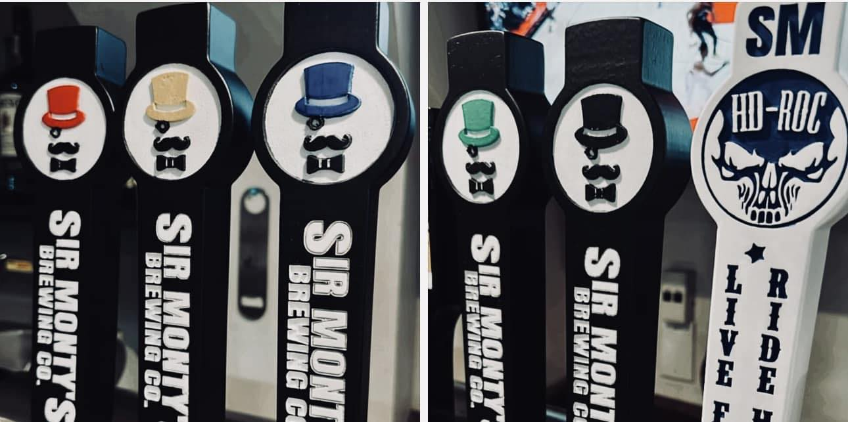

Sir Monty's Brewing Company
1540 Durham Regional Hwy 2, Courtice, ON L1E 2T5

Wednesday April 16th 2025
8pm-11pm

In honor of their son Luke, the Parkinson family (co-owners of Sir Monty’s) have arranged for a craft beer in recognition of BFO Durham. For every can sold, 50c will go to BFO

“BFO blonde.”

“BFO Blonde” is in memory of our son Luke Parkinson. Luke tragically took his own life at the age of 21 and during this dark time, Bereaved Families of Ontario - Durham Region, provided critical mental health assistance to our family.
BFO Durham is a non-profit organization which has been supporting families in the Durham Region for over 25 years.
From every sale of a can, 50c will go towards BFO Durham to help the families that were put in the same position as our family was.

Cheers from the Parkinson Family!

